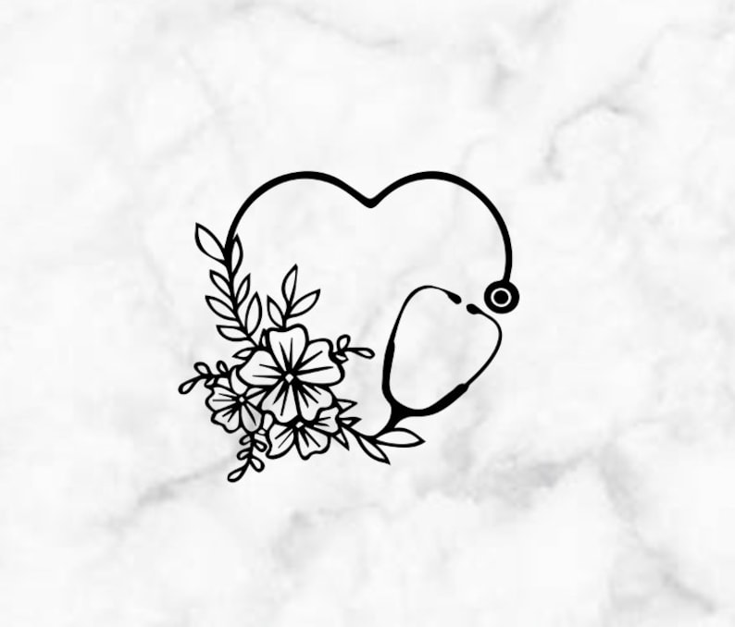

- Where Hufflepuff is written would like Amanda Pearl
- Would like the stethoscope heart encasing around the Hufflepuff design
- Want the stethoscope to be designed like the lower right one, with flowers from the upper heart on the right side of the stethoscope as opposed to the left
- Would like the stethoscope to be red and the flowers can be whatever color that really looks sharp/nice with the logo
- The design can be altered artistically – I am open to suggestions.

